**Ideation Phase**

**Define the Problem Statements**

|  |  |
| --- | --- |
| Date | 15 October 2022 |
| Team ID | PNT2022TMID01351 |
| Project Name | News Tracking Application |
| Maximum Marks | 2 Marks |

**Problem Statement:**

Robert is a businessman who's busy 24/7, so he has practically no time to consume news through the form of a physical newspaper and it's difficult for a person like him to carry a physical newspaper, because he travels a lot to attend his business meetings. And it's difficult for him to select the kind of news which interests him and also useful for him, so if he goes for a physical newspaper it's going be a time consuming task. So with the help of a application it's easier for him to read the kind of news he wants to consume and the news which actually keeps him well informed in his desired field despite his busy schedule and travel..

|  |  |
| --- | --- |
| I am | Mr.Robert, a business man of a xyz company. |
| I’m trying to | Consume news despite my busy schedule. |
| But, | I’m finding it difficult to consume news through the form of a physical newspaper as, I travel a lot |
| Because | Of travel schedules ,I rely on an app to keep me informed. |
| Which makes me feel | The concept of a physical newspaper causes congestion during travel. |

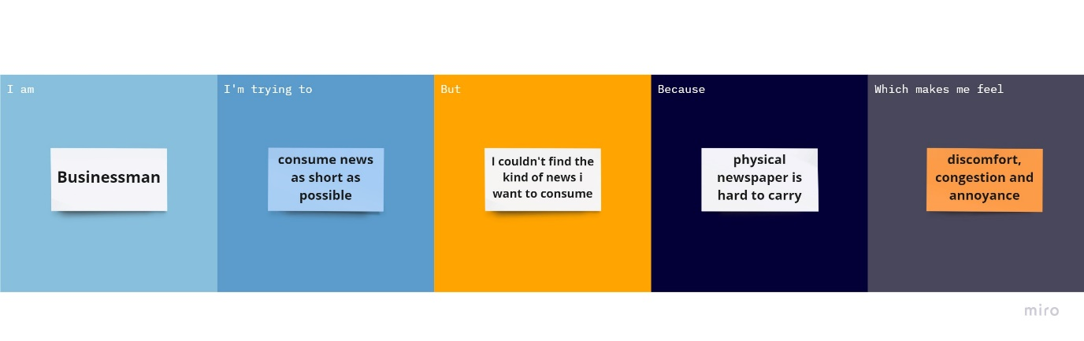

|  |  |  |  |  |  |
| --- | --- | --- | --- | --- | --- |
| **Problem Statement (PS)** | **I am (Customer)** | **I’m trying to** | **But** | **Because** | **Which makes me feel** |
| PS-1 | Business Man | Read news while travelling | I couldn’t have enough time to read | It feels like a burden to carry a news paper. | Discomfort and more annoying |
| PS-2 | Business Man | To get the information at any time. | I couldn’t able to carry the news paper | It’s not convenient for me to carry the news paper wherever I go. | Congestion and annoyance. |